**Healthcare in prison**

**Unit 2**

**Talking about my health**



**English to help you understand how to get help when you are ill in prison**

**Contents**

|  |  |
| --- | --- |
| Workbook learning goals | Page 3 |
| Workbook 2 – Health problems: Task 1 | Page 4 |
| Workbook 2 – Health problems: Task 2 | Page 6 |
| Workbook 2 – Health problems: Task 3 | Page 8 |
| Workbook 2 – Health problems: Task 4 | Page 9 |
| Workbook 2 – Health problems: Task 5 | Page 11 |
| End of Workbook check | Page 13 |
| Workbook 2 Answer key | Page 14 |

People get ill in prison just like they do outside prison. This means you will probably need to see a doctor or someone in healthcare.

Learn some words to talk about how you feel.

**Learning goals**

By the end of this unit you will be able to:

* use words to describe how you are feeling
* learn the names of some illnesses
* understand questions a healthcare worker will ask you

**Task 1 – Health problems**

1. **Who has a health problem?**

Here are two men, Pete and Francis. Tick (✓) who is ill or has a health problem.

|  |  |
| --- | --- |
|  | C:\Users\owner\Dropbox\istock images\man_smiling.jpg |
| ❑ Pete | ❑ Francis |

1. **Name the problem (or symptom)**

Pete has toothache. It hurts! Write the words from the box under the correct picture on the next page.

a runny nose asthma ~~toothache~~ earache a sore throat

a headache a bruise backache chest pain

a swollen ankle a cough a high temperature

|  |  |  |
| --- | --- | --- |
|  |  |  |
| 1. | 2. | 3. toothache 🖉 |
|  |  |  |
| 4. | 5. | 6. |
|  |  | \\Uk_lon1b_ms101\home$\JulieDay\Documents\Offender\stressed.jpg |
| 7. | 8. | 9. |
|  |  |  |
| 10. | 11. | 12. |

**Task 2 Read a conversation: speaking to a PID** (PID =Prisoner Information Desk)

**Man**: Hello. I feel ill. Could I see a doctor please?

PID worker: What’s the matter?

**Man**: I’ve got a bad headache and a sore throat. I want to rest in cell.

PID worker: Have you filled in an app or an application?

**Man**: No, I haven’t. I asked the officer for an app... and he told me to speak to you.

PID worker: OK that’s fine. Fill it in now and then put it in the medical box. Write something here too about how you feel.

**Man**: When can I see a doctor?

PID worker: It depends. If you fill in an app, you will see a doctor as soon as possible.

**Man**: Thanks for your help.

PID worker: No problem, mate.

Read the conversation and answer the questions. Tick (✓) the answers.

1. What’s wrong with the man?

❑ He’s got toothache

❑ He’s depressed.

❑ He has a headache and sore throat.

1. How can the man get an appointment with a doctor?

❑ Fill in a form called an app.

❑ Ring the doctor.

1. When can the man see a doctor?

❑ Tomorrow.

❑ They don’t know.

**Grammar: have got / has got**

*He’s got* a headache and a sore throat.

1. Write the words into the table.

they’ve ~~I’ve~~ he’s we’ve she’s you’ve

|  |  |  |  |
| --- | --- | --- | --- |
| I have  = I’ve 🖉 | got | a | headache. |
| you have  = | got | a | sore throat. |
| he has  = | got | - | earache. |
| she has  = | got | - | asthma. |
| we have  = | got | a | cough. |
| they have  = | got | a | nosebleed. |

**Grammar: word order**

got / a / headache / have / I

**I have got a headache.** 🖉

He / asthma / got / has

1. \_\_\_\_\_\_\_\_\_\_\_\_\_\_\_\_\_\_\_\_\_\_\_\_\_

nosebleed / got / I / ‘ve / a

1. \_\_\_\_\_\_\_\_\_\_\_\_\_\_\_\_\_\_\_\_\_\_\_\_\_

You / a / cough / ‘ve / got

1. \_\_\_\_\_\_\_\_\_\_\_\_\_\_\_\_\_\_\_\_\_\_\_\_\_

**Task 3 – Saying how you feel**

What’s he saying to the doctor?

1. ****

I’ve got **backache**. 🖉

1. ****

I’ve got \_\_ \_\_\_\_\_\_ \_\_\_\_\_\_\_.

1. 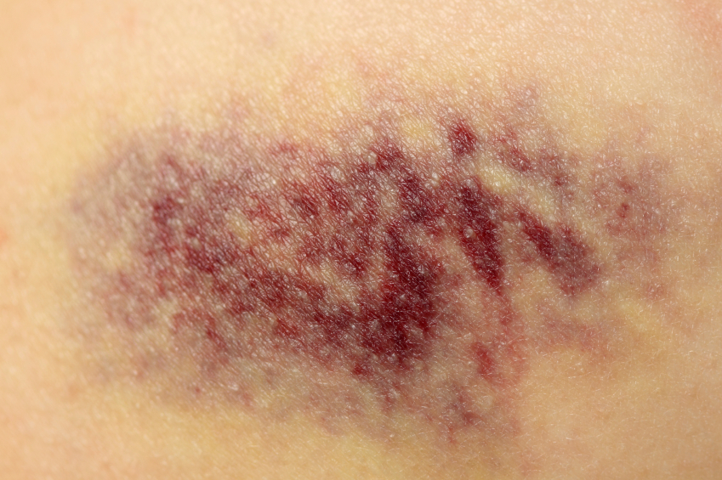

I’ve got a \_\_\_\_\_\_\_\_\_\_ on my arm.

\_\_\_\_\_\_\_ \_\_\_\_\_\_\_ \_\_\_\_\_\_\_\_\_\_.

1. 
2. 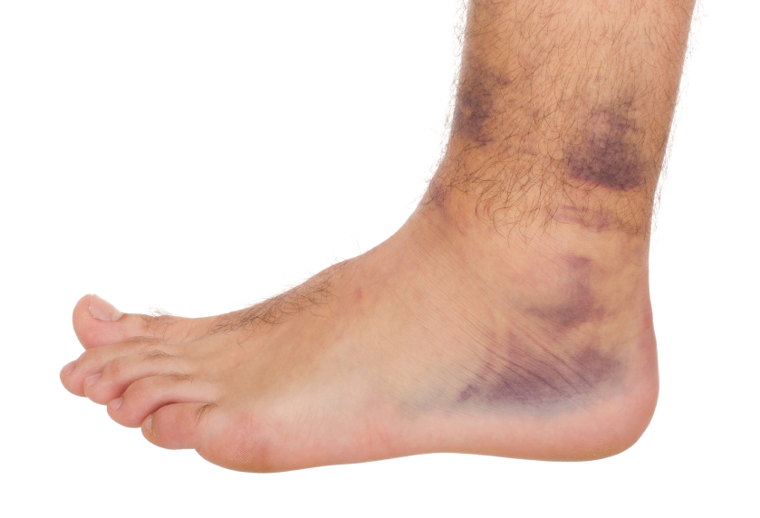

**Task 4 – Questions and illnesses**

**Before you start:**

Look at these sentences:

These are **painkillers** or tablets.

Many people have **allergies**. Some people are **allergic to** milk, nuts or bread.



I’m allergic to nuts. I can’t eat them. They make me ill.

Do you have any allergies? \_\_\_\_\_\_\_\_\_\_\_\_\_\_\_\_\_\_\_\_\_\_\_\_\_\_\_\_\_\_\_\_\_\_\_\_\_\_\_\_\_

**Here are some questions a healthcare professional might ask you. Match the question with the answer.**

1. What’s the matter? a. Yes, I took some painkillers.
2. Where does it hurt? b. Yes, I do. I’m allergic to milk.
3. Have you got a temperature? c. I feel sick.
4. Have you taken anything? d. Since Monday.
5. Do you have any allergies? e. No, I don’t think I have.
6. How long have you felt sick? f. In my neck.

**Task 4b – These men don’t feel very well. What’s wrong?**

I feel down

all the time.

I can’t see very well.

 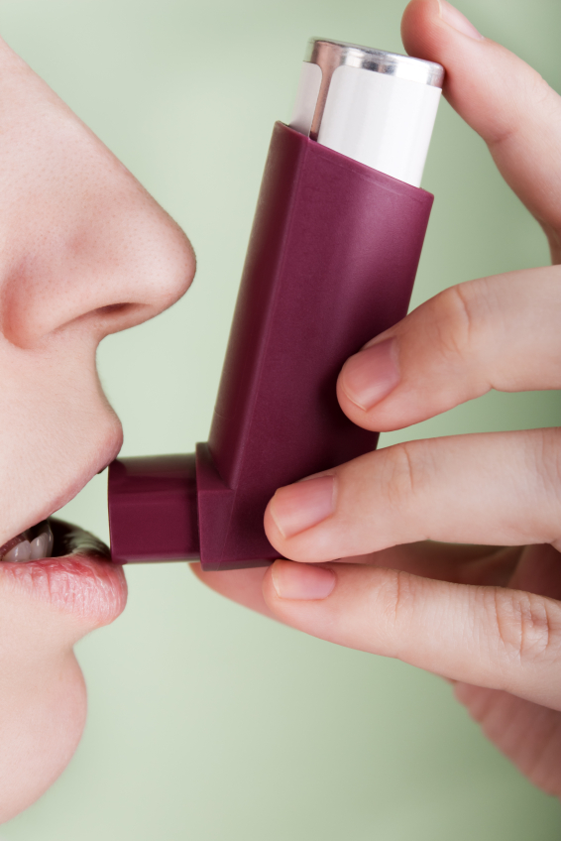 

4

2

1

3

Match the sentence with the illness.

1. I feel down all the time. diabetes
2. I can’t see very well. depression
3. I feel really weak. I need some sugar. asthma
4. I can’t breathe. a cold
5. I’ve got a sore throat and runny nose. eye problems

**Task 5: Health wordsearch**

Find these words in the puzzle:

bruise cold cough depression

earache flu pain sick

sore symptoms swollen toothache 🗸

|  |  |  |  |  |  |  |  |
| --- | --- | --- | --- | --- | --- | --- | --- |
| s | y | m | p | t | o | m | s |
| w | d | a | t | o | r | o | o |
| o | e | z | c | o | l | d | r |
| l | p | b | y | t | a | q | e |
| l | r | t | o | h | z | t | i |
| e | e | i | p | a | i | n | b |
| n | s | q | b | c | t | y | u |
| y | s | e | u | h | u | r | t |
| d | i | a | b | e | t | e | s |
| s | o | r | w | y | o | r | z |
| a | n | a | z | b | c | p | b |
| s | i | c | k | o | o | a | r |
| b | j | h | i | t | u | u | u |
| t | r | e | a | t | g | i | i |
| u | x | b | k | o | h | r | s |
| f | l | u | r | y | i | y | e |

**Word list – new words about my health. Add any more new words you have learnt in the spaces at the bottom.**

Write the word in your language.

|  |  |  |  |
| --- | --- | --- | --- |
|  |  | symptom | translation |
| I’ve got | a | headache |  |
|  | - | backache |  |
|  | - | earache |  |
|  | - | stomach ache |  |
|  | - | toothache |  |
|  | - | chest pain |  |
|  | - | diarrhoea |  |
|  | a | bruise |  |
|  | a | blister |  |
|  | a | cough |  |
|  | a | runny nose |  |
|  | a | swollen ankle |  |
|  | a | sore throat |  |
|  | a | temperature |  |
|  | a | nosebleed |  |
|  |  |  |  |
|  |  |  |  |
|  |  |  |  |

**End of unit check**

Now you have finished this unit, how do you feel? Tick (✓) the box that is true for you.

|  |  |  |  |
| --- | --- | --- | --- |
|  | Yes | A little | No |
| I can use words to describe how I am feeling. |  |  |  |
| I can say the names of some illnesses. |  |  |  |
| I can understand questions a healthcare worker will ask me |  |  |  |

**Answer key: Workbook 2 – Talking about your health ()**

**Task 1**

1. Pete

**1.2**

1. earache
2. asthma
3. a runny nose
4. a sore throat
5. toothache
6. chest pain
7. backache
8. a swollen ankle
9. a headache
10. a cough
11. a bruise
12. a high temperature

**Task 2**

1. He has a headache and sore throat.
2. Fill in a form called an app.
3. They don’t know.
4. you’ve, he’s, she’s, we’ve, they’ve
5. He has got asthma.
6. I’ve got a nosebleed.
7. You’ve got a cough.

**Task 3**

1. I’ve got backache.
2. I’ve got a sore throat.
3. I’ve got a bruise.
4. I’ve got a toothache.
5. I’ve got a swollen ankle.

**Task 4**

1. c
2. f
3. e
4. a
5. b
6. d

**Task 4b**

1. depression
2. eye problems
3. diabetes
4. asthma
5. a cold

**Task 5**

|  |  |  |  |  |  |  |  |
| --- | --- | --- | --- | --- | --- | --- | --- |
| s | y | m | p | t | o | m | s |
| w | d | a | t | o | r | o | o |
| o | e | z | c | o | l | d | r |
| l | p | b | y | t | a | q | e |
| l | r | t | o | h | z | t | i |
| e | e | i | p | a | i | n | b |
| n | s | q | b | c | t | y | u |
| y | s | e | u | h | u | r | t |
| d | i | a | b | e | t | e | s |
| s | o | r | w | y | o | r | z |
| a | n | a | z | b | c | p | b |
| s | i | c | k | o | o | a | r |
| b | j | h | i | t | u | u | u |
| t | r | e | a | t | g | i | i |
| u | x | b | k | o | h | r | s |
| f | l | u | r | y | i | y | e |