Lesson plan
Countries I Know

Level: Beginner – Entry 3, Scottish National 1 - 4
Time: 90 minutes

Aims
- To be able to talk about my country and culture
- To develop free speaking skills
- To develop free writing skills (extension work)

Objectives
All learners will
- develop vocabulary relating to countries and cultures
- be able to ask and answer questions about different countries
- make statements about countries they know
- form questions: the wh– type and the yes/ no type
- respond to simple questions on basic facts about countries and culture

Learners at Entry 2 / National 3 and above will be able to:
- use question form of simple present and simple past of common verbs and verbs be, do, have, wh– forms, how much / many
- follow up a response to their question to continue the conversation,
- compare and contrast, using comparatives where appropriate.
- ask for clarification, with appropriate use of intonation

Introduction
This lesson helps learners to develop their speaking and listening skills using a context in which they are an expert. Exchanging information about their backgrounds and cultures should help boost confidence, foster better relationships and mutual understanding. It could be used to introduce a series of lessons on countries and cultures with plenty of opportunities for extension work and the creation of colourful and personal classroom displays.

You will need:
- Resource 1: images, cut up, enough copies for one between three / four learners. You only need the first 6 for lower level learners.
- Resource 2: questionnaire, one for each group
- Resource 3: images, one copy for each learner
- Large sheets of blank paper and coloured markers / felt pens
- Large world map showing country boundaries to display or project, or an atlas.
- If you have the time and facilities, download and print/project images from learners’ countries to use to stimulate discussion.

Procedure
Warmer (5-10 minutes)
- Display the world map and check that learners know what it is and what countries are. You could ask ‘What is this?’ to elicit, ‘It’s a map of the world’. Do the same for relevant countries.

Tip! Learners who have had little education may not be able to ‘read’ a map i.e. understand that blue represents sea, rivers, etc. or that a map represents geographical and political features pictorially. You may need to spend some time making this clear.

- Point out the United Kingdom, or the country you are in and say ‘I’m from the United Kingdom / Britain / England / N. Ireland / Scotland / Wales.’ If you were born in another country you can explain that later.
- Elicit the country each learner comes from – ‘Where are you from?’
- Ask each learner to point out their country on the map, supporting as necessary.

Activity 1 – Tell us a little about you: questions (15 minutes)
- Tell learners they are going to learn about each other’s countries – either the place they were born or another country they know well where they lived. You are going to use questions starting with ‘Wh….?
- Write Wh ……..? on the board and ask learners if they can think of words that start a question starting with these letters: ‘What, where, when, which, who?’ Include ‘why’ if it’s offered but tell them you won’t be using it in this activity.
- Tell learners you are going to practise using these question words starting with ‘where’. Start by saying to a confident learner; ‘I’m from Britain, (or the country you are from) where are you from?’ Demonstrate the falling intonation at the end of the’ Wh?’ questions and drill it.
- When he / she has answered the question, invite him / her to ask another member of the group the same question.
- Continue until all class members have asked and answered the question.
- Repeat this process with another two questions e.g. ‘What language do you speak? What religion is your country? What money do you use in your country?’
- If this is just revision of ‘Wh..?’ questions for your learners, add ‘Yes/ No’ questions: ’Is it very hot in your country? Do people watch sport?’ Draw their attention to the rising intonation for this type of question, and drill it as before.
- Invite learners to ask someone else a question of their own, even if they just use a word e. g. ‘food? ..weather?’ Just model saying it correctly and move on as at this stage you want to encourage fluency.

Differentiation
- Nominate confident learners to answer first so the others can hear a good model. However, make sure that all learners have a chance to speak.
- Encourage advanced learners to expand on their responses and use full sentences for their questions.

Activity 2 – Finding out more (10-15 minutes)
- Group learners by ability in pairs or small groups of 3 or 4. Handout resource 1 with images symbolic of different cultural features.
- Give the lower ability group up to six images and ask them to work in pairs to ask each other questions and answers about each image.
- Let the more advanced group/s work on their own with all the images while you support the lower level learners initially.
- Monitor and support the more advanced group once the lower level learners are able to work with a new partner to ask and respond to questions.

Extension
- More advanced learners can write down their questions and their partner’s responses if they finish early.
- They could also scribe for lower-level learners.

Activity 3 – Questionnaire (10-15 minutes)
- Handout resource 2 and pair each learner with someone from a different country to complete the questionnaire about themselves and their partner. If numbers are uneven work with the learner who needs most support.
- Elicit the questions necessary to complete the questionnaire.
- Upon completion invite learners to join another pair, or two pairs if you have a large class, and ask them to take turns to tell their group three things they have learnt about their partner.
- Check learning by moving between groups and ask other learners questions about what they are hearing to encourage good listening skills e.g. ‘Where is he from? What language does he speak?’ Make a note of common errors made.
- Feedback with corrections to some errors learners made but do not try to correct all mistakes.

Extension
Learners could write questions and answers and / or add new ones.

Activity 4 – Learning more: freer discussion (20 minutes)
- Select, or ask learners to choose an aspect they would like to talk more about.
- You may want to focus on food and festivals which should be less contentious than others. They may prefer sport, arts, music, language or something else.
- Use the images from resource 3, which mainly focuses on the UK, as stimulus.
- Take the opportunity to introduce or revise comparatives e.g. Scotland is colder than Nigeria, food is spicier in Pakistan than Poland.

Tip! Be careful not to let this stage get too teacher-centred so the learners have as much chance to speak as possible. If you have a large class split them into mixed ability groups and make sure that everyone has a chance to contribute at their level by encouraging learners who share the same language to support each other. Encourage them to use mime, gestures or drawings to get their point across.
- Encourage free discussion only intervening to support understanding and to ensure that each learner has an opportunity to speak. Ask ‘What do you think? What happens in your country? Is it the same / different in your country?’
- There may be enough discussion on food but if the occasion arises e.g. ‘we eat chocolate eggs at Easter’, ask other learners about special foods they eat at festivals or special occasions such as birthdays.
- Ask each learner to name a festival in their country or town and encourage other learners to ask more questions about it e. g. ‘What do you do? Do you have special food? Is there music? Do you dance? What clothes do you wear?’
- Give each learner about a minute each. Encourage advanced learners to ask follow up questions and give fuller answers. If there’s more than one learner from a country they can take it turns to respond.

Extension
Learners could be given a grammar activity on comparatives according to their level.

Activity 5 – Poster/s 15 – 20 minutes
- Create a class poster or colourful calendar to record some of the learning from the session depending on what will be most useful for the group.
- For the ‘calendar’, you could just divide a flip chart sheet into 12 squares and invite learners to say which month goes into each square. Ask a confident learner to write or get the group to spell the month while you write, pausing if they get a letter wrong to allow them to try again.
- Learners fill in the calendar with the name and date (if known) of each festival, add their birthdays if they wish, and any other significant dates. They could add illustrations of food or other items associated with each event.
- Use it regularly to commemorate events and update it once non-fixed festival dates are known.
- Alternatively they could create a poster or posters with words and illustrations of each country with whatever information they agree on.

Cooler (5-10 mins)
- Invite each learner to tell the class one new thing each that they have learnt about the country or culture of another member of the group today.

Extension activities / Homework
- Writing activities: learners could write a short piece about themselves and decorate the sheet with pictures of the countries, flags, maps etc. relating to their country for display.
- Another extension/ follow-up activity could be a phrase sheet so they could share greetings, please, thank you etc. in their own languages.
- Higher level learners could write a quiz about their country or the countries they have learnt about in this lesson to ask the others the next time they meet. This could include comparatives.

Resource 1

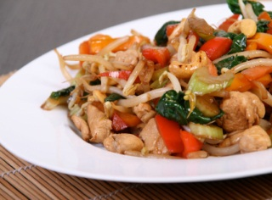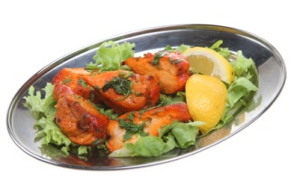  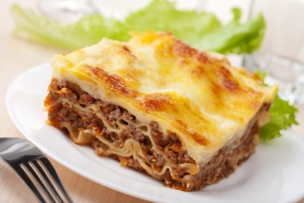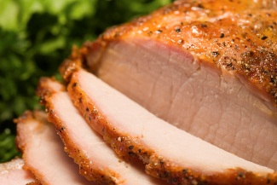  food |     sport
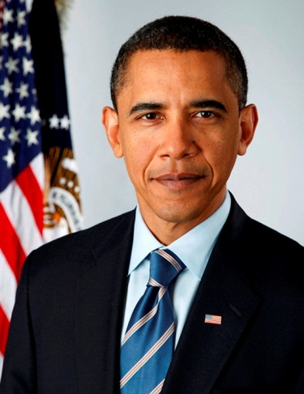  famous person | 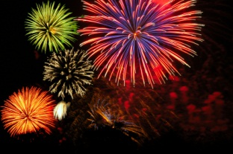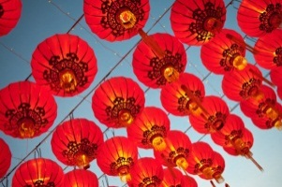  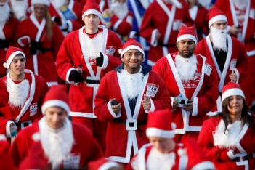  festival
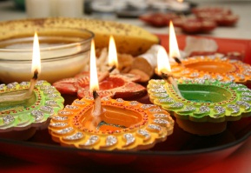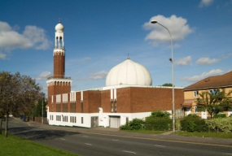  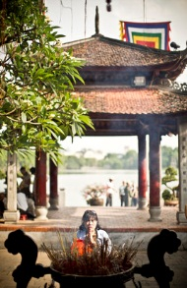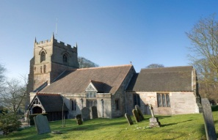  religion | 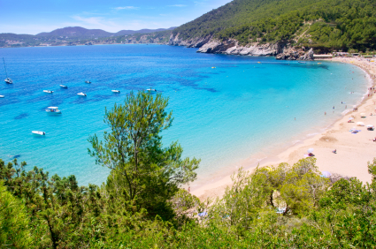  coast

  city | 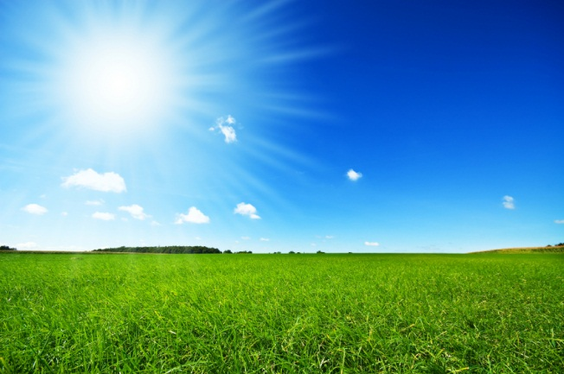  countryside
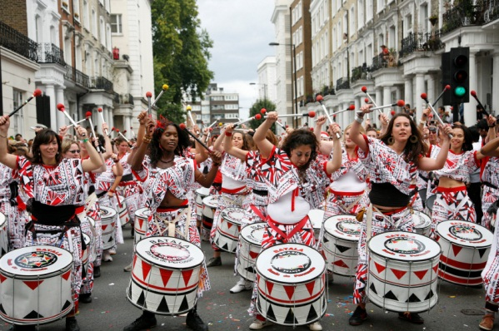  music and dance | ?  ?  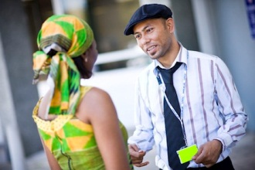  language
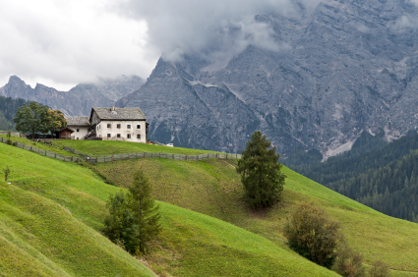  mountains | $ € ¥ ৳ Rs ع.د  Sh ﷼ Ls zł руб  RSD ₫; DT ₪ KR  money

Resource 2

Make the question starting with What? Where? Who?
Answer the question yourself by filling in the boxes.
Ask your partner and fill in the boxes.

Question | Me | Other student(s)
Name?

From?

Language?

Money?

Festivals?

Food?

Famous person?

Resource 3

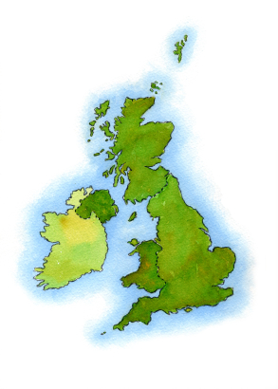  Where………? | weather  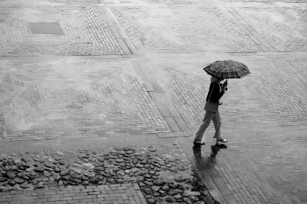
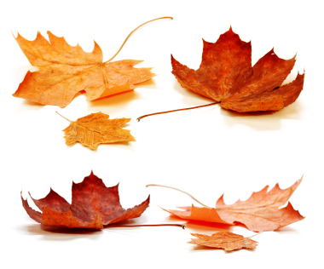  seasons | 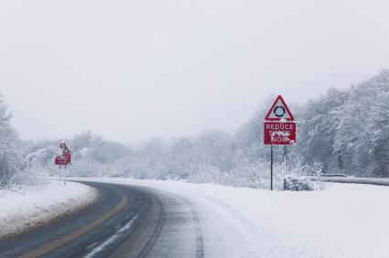
 | 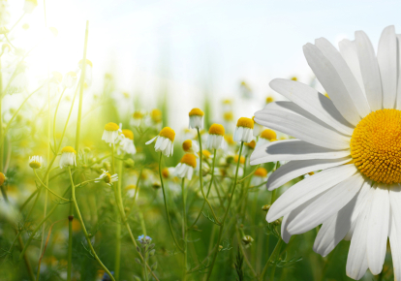

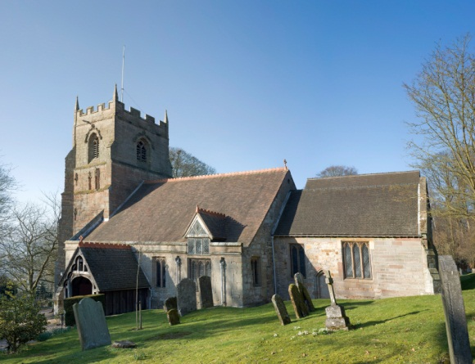 | 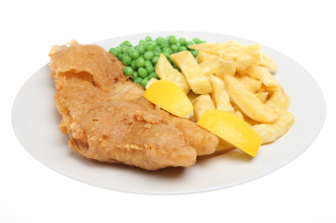
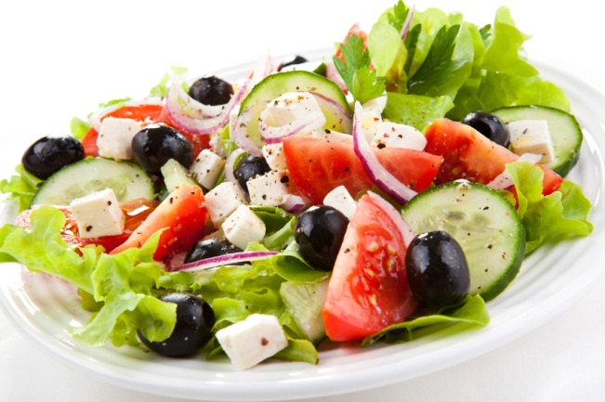 | 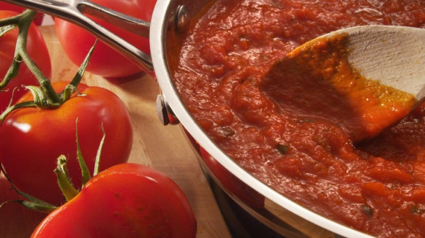
 | 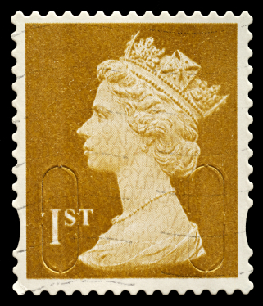

Add your own images here | Add your own images here
Add your own images here | Add your own images here
Add your own images here | Add your own images here
Add your own images here | Add your own images here

