**Pre-vocational training**

**Unit 3**

**Hairdressing**

**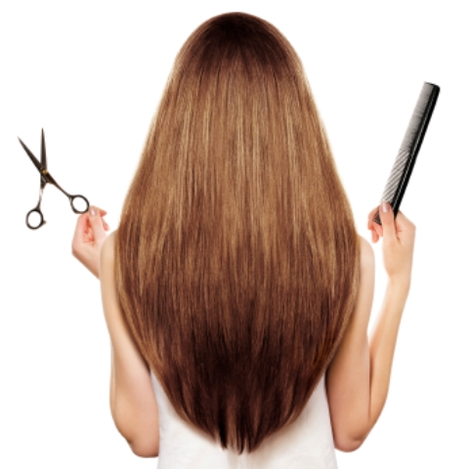**

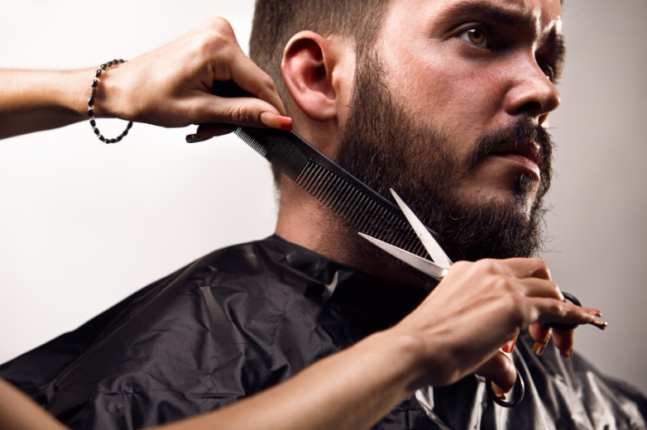

**Contents**

**Unit 3 Hairdressing: teachers’ notes**

**Unit 3 Hairdressing: answers**

**Unit 3 Hairdressing: resources**

**Unit 3 Hairdressing: audios TP\_PreVoc\_U3\_Hairdressing\_Marta.mp3**

**TP\_PreVoc\_U3\_Hairdressing\_Asan.mp3**

**Copyright - please read**

All the materials on these pages are free for you to download and copy for educational use only. You may not redistribute, sell or place these materials on any other website without written permission from the British Council. If you have any questions about the use of these materials please email us at: [esolnexus@britishcouncil.org](mailto:esolnexus@britishcouncil.org)

**Unit 3 – Hairdressing**

This resource is designed to prepare ESOL learners to do a vocational course while in prison. It provides an introduction to terminology associated with studying to become a hairdresser. In addition to focusing on language needed to work in hairdressing, learners will be introduced to common practices associated with working in a salon, including talking to clients and reading typical texts.

**Entry level 1-3 / Scottish National 2 - 4 / CEFR A1 - B1**

**Time**: Around 2 hours. Timings are flexible and teachers can break down the units into smaller chunks of learning and build in revision as required

**Aims**

* to introduce some salon vocabulary for different hair treatments, equipment and products
* to provide opportunity to practise typical salon communication between salon staff and clients
* to read and understand common salon texts

**Objectives**

By the end of the session,

Pre-entry learners will be able to;

* recognise vocabulary for at least 4 types of treatment commonly offered in a hair salon
* use prompts to carry out simple dialogues to make an appointment
* recognise and use vocabulary for at least 3 items of equipment or products commonly used in a hair salon which are also used in everyday life
* read, write and say prices
* greet a client in a simple dialogue

Entry 1 – 2/ National 2- 3 learners will be able to;

* recognise vocabulary for at least 10 types of treatment commonly offered in a hair salon
* make an appointment for a treatment
* recognise and use vocabulary for at least 10 items of equipment or products commonly used in a hair salon
* read and understand the purpose and some detail of five salon texts (price list, appointment book, instructions, sign and order form)
* identify appropriate and inappropriate comments and questions for the salon

In addition, Entry 3 / National 4 learners will be able to;

* use vocabulary to choose a treatment
* identify silent letters in salon vocabulary
* deduce the meaning of unfamiliar vocabulary used in salon texts

**Preparation**

**You will need:**

* Mini-whiteboards, markers and tissue paper (one per learner). You can create mini-whiteboards by laminating A4 sheets, or give each learner a few sheets of paper.
* Pictures of people with different types of hair (e.g. cut from magazines)
* **Resource 1** – salon images. One large copy, or display on an interactive white board (IWB).
* **Resource 2** – salon treatment vocabulary cards. Cut up, one set per group of three or four learners, in colour if possible. Also, display on IWB if possible.
* **Resource 3** – salon price list. One copy per learner for Entry 1 to 3. Also display on IWB if possible.
* Authentic salon price lists (if you have higher level learners).
* **Resource 4** – price list information gap (optional, as an extension activity to practise prices). One per pair of learners.
* **Resource 5a**– listening activity. One per learner, **5b** 1 per higher-level learner.
* **Resource 6** – transcript. One copy for you and (optional) cut into strips, one set per pair of learners.
* **Resource 7a** –appointment book. One per pair of entry level learners, folded or cut where indicated. **Resource 7b** – prompts. One per pair of pre-entry learners.
* **Resource 8** – salon items worksheet. One per group of three or four learners, folded where indicated.
* **Resource 9** – salon texts and activity. One per learner.
* **Resource 10** – talking to your client activity. One per pair of entry level learners.

**Consider:**

* Try to get a copy of your prison’s canteen list. Learners can identify haircare products and equipment. See follow-up activity in Activity 4.
* Look into the hairdressing and barbering courses run in your prison. Ask about the level of English learners need to access these courses and collect leaflets or course information sheets to give to interested learners.
* Invite a tutor from the hairdressing course to come and speak to your learners about the things they could learn on the course.
* There are other useful materials available online from Excellence Gateway <http://www.excellencegateway.org.uk/vocabulary/EGCurriculumArea/Hairdressing%20and%20beauty%20therapy> and the BBC <http://www.bbc.co.uk/skillswise/topic/hair-beauty-and-fashion> They may need adapting for your learners’ levels.

**Procedure**

**Warmer Describing hair (15 minutes)**

* Elicit or give the following vocabulary for describing hair*; short, mid-length, long, straight, wavy, curly*. Draw pictures on the whiteboard / flipchart to do this.
* Drill the words then point to your own hair (or use a picture) and ask the learners what kind of hair you have got (or the hair type in the picture).
* Distribute the mini-whiteboards / scrap paper and marker pens. (If you are using mini-whiteboards, also hand out tissue paper / mini-whiteboard cleaners.)
* Instruct learners to draw a large face without hair, e.g.☺ Demonstrate this on your mini-whiteboard.
* Hold your mini-whiteboard so that the learners cannot see it. Draw some long straight hair on your picture and tell the learners ‘*I’ve got long straight hair*.’ Indicate that the learners should draw what they hear.
* When everyone has finished drawing, ask the learners to hold up their whiteboards / scrap paper as you reveal your picture.
* Repeat several times with different combinations of hair types.
* At the end of the game, drill the phrase ‘I’ve got.......hair.’ If you think your learners will be comfortable with it, ask them to describe their hair to their partner.
* If you think they won’t be comfortable, drill ‘He/ she’s got.....hair.’ Give your learners some pictures of people with different types of hair and ask them to describe the pictures.

**Differentiation**

* If you think your learners can handle it, elicit / drill a greater range of words, e.g. beard, moustache, bald, ponytail, a scar, an earring etc. and add those features to your drawing.

**Learning check**

* Check the pictures learners have drawn are similar to yours to make sure they’ve understood the vocabulary.

**Activity 1 Hair salon price list (20 minutes)**

* Show **resource 1** – the picture of a hair salon.
* Ask a few lead-in questions to stimulate interest in the topic, e.g. *Where are they? Do you like the salon / barbers here? How often do you go to the salon / barbers? What are their jobs? Would you like this job?*
* Explain that today’s lesson is about hairdressing and some of the language you will need if you want to work in a salon.
* Rearrange the learners so that they are in mixed ability groups of three or four. Pre-entry learners could work in their own level group, with support if you have it.
* Give one set of pictures (**resource 2**) to each group of learners and ask them to explain to their group what they can see in each picture.
* After a few minutes, get some feedback. Display / hold up each picture and elicit the following vocabulary; *clippers, cut, dry cut, wet cut, trim, beard trim, shave, wet shave, wash, blow dry, style, colour, permanent colour, semi-permanent colour, cane rows / corn rows, weave, extensions.* Elicit explanations from your learners where possible, using concept check questions to do so, e.g. for permanent, ask *Will my colour last a long time?* If learners suggest any other useful vocabulary relevant to the pictures, write them up on the whiteboard (e.g. *hairdryer, razor*) and encourage learners to explain their meaning.
* Drill each word.
* Display / hold up a copy of the salon price list (**resource 3**). Elicit (perhaps from higher level learners) the text type (price list) and why you read it (to know the treatments and how much they cost).
* Demonstrate the price list matching activity by asking learners to read the first item on the price list (clippers) and ask which number picture this is (picture 5). Demonstrate writing the number in the box to the left of ‘clippers’.
* Distribute the price lists (**resource 3**) and allow the learners some time to complete the matching activity.

**Differentiation**

* Give pre-entry learners fewer words. This can be done by folding **resource 3** so that only the gents’ or the ladies’ treatments are visible and removing the unnecessary pictures from **resource 2**.
* The questions at the bottom of **resource 3** can be used as an extension to stretch lower-level learners.
* Give higher level learners finishing quickly an authentic salon price list and ask them to look for any of the treatments in the pictures that are listed.
* Tell them they have £30 to spend in the salon and ask them what they are going to choose. They tell their partner and give a reason for their choice.

**Learning check**

* Monitor whilst learners peer teach each other vocabulary.
* **Resource 3** checks learners have understood vocabulary for hair treatments shown in the pictures.

**Follow up / extension activities**

* Practise reading and writing numbers and prices. Put learners in pairs; Learner A and B. Give all the Learner As **resource 4A** and all the Learner Bs **resource 4B**. They must ask and answer questions using *How much is a....?* or *How much are...?* to fill in the gaps on their sheets. They compare their answers at the end of the activity.
* Learners work in a group. Tell them they run their own salon. They must think of a name for the salon and decide which treatments they will offer. They design their own price list / leaflet for the salon.

**Activity 2 Making appointments listening activity (10 minutes)**

* Re-arrange the learners so people of a similar level are seated together.
* Ask learners to listen to the first dialogue (Marta) and answer the following questions which you should write on the whiteboard / flipchart; *Where are they? Who is speaking? What do they want?*
* Play Dialogue 1 of the **audio** once, then have learners discuss in pairs the answers to the questions. After a minute or two, invite learners to answer the questions. (*Answers: Where are they? The reception of a salon. Who is speaking? A receptionist and a client / customer. What do they want? To make an appointment.)*
* Hold up a copy of **resource 5**a. Explain that learners must listen again, this time to two dialogues and choose the correct information and tick the box (Task 1A) OR fill in the information (Task 1B) (see differentiation below).
* Give learners a little time to read the task before playing both dialogues.
* Allow them to check in pairs, then play again if necessary.

**Differentiation**

* Do not give pre-entry learners **resource 5**. Instead, give them a selection of pictures from **resource 2,** making sure *cut and style*, *wet cut* and *beard trim* are included. Learners listen and select the treatments they hear.
* Entry 1 / National 2 can complete the less challenging Task 1A in **resource 5a**.
* Entry 2 / National 3 and above can attempt Task 1B in **resource 5b**.
* As an additional activity to stretch higher level learners, give them a cut up transcript (**resource 6**) and ask them to re-order the lines of the dialogue as they listen.

**Learning check**

* Avoid monitoring during the listening activity itself as this can distract learners. Instead, have the learners check in pairs immediately after listening. At this point, listen in and check how they are doing, and assess whether or not they need to listen again.
* At the end of the tasks on Resource 5, display the worksheet (if possible) and conduct whole class feedback, inviting answers from your class.

**Activity 3 Making appointments role-play activity (20 minutes)**

* Use gapped texts on the whiteboard to elicit some of the phrases from the listening activity, e.g. *.................. I ...................... an appointment for a ..............., please?* See the phrases highlighted in the transcript for useful language to elicit here.
* Drill the phrases using substitution drills for different times / treatments. (See box below for an explanation if you haven’t used these before.)
* Show the image of a receptionist and customer from **resource 1** again.
* Allocate roles to each of the learners. Make more confident speakers ‘receptionists’ and the less confident ones ‘clients’. There should be about the same amount of both roles.
* Seat the ‘receptionists’ dotted around the classroom. Explain that they have to book clients in for appointments. They cannot book two clients at the same time. Give each receptionist an appointment book (**resource 7a**) and tell them to think of a name for their salon which they should write at the top of the sheet.
* Whilst they do this, prepare the ‘clients’. Tell them they have to decide which treatment or treatments they want, and then make appointments at the various hair salons.
* Playing the role of a client, demonstrate the role-play with a confident ‘receptionist’.
* Learners carry out receptionist – client role-plays, changing partners frequently, until every client has spoken to every receptionist.

**Differentiation**

* Make more confident speaker the ‘receptionists’.
* Pre-entry learners work in pairs (with support if you have it) to carry out a simplified role-play using the prompts (**resource 7b**), e.g.
* *Client Can I have an appointment, please?*
* *Receptionist Monday at 2.00?*
* *Client OK.*
* *Receptionist What’s your name?*
* *Client (gives name)*
* *Receptionist OK. Bye.*

**Learning checks**

* Monitor unobtrusively for examples of good language you hear as well as commonly occurring errors and write them up on the board / flipchart at the end of the activity.
* Ask learners to read the phrases and discuss with their partners which are good and which have mistakes.

**Activity 4 Salon vocabulary (15 minutes)**

* Arrange the learners so they are sitting in same-level groups.
* Display the pictures from **resource 1** again. Point to the mirror and the comb and elicit the names of these items. Invite the learners to suggest what other equipment you need when you work in a salon.
* Give out **resource 8** (salon items), folded where indicated, to each group of three or four learners and ask them to tell each other the names of the items.
* After a minute or two, ask them to unfold the sheet and match the words at the bottom to the items they see. Nominate one learner per group to write the relevant word under each picture.
* Drill the words at the bottom of **resource 8** chorally and individually.
* Write up these three treatments on the whiteboard / flipchart; *cut and style, beard trim, wet cut*. Ask the learners to decide in their groups which items they need for each of these treatments.

**Differentiation**

* Pre-entry learners just focus on a few key words, e.g. *brush, shampoo* and *towel* which are useful for everyday life. They can copy the words out and practise the spelling and pronunciation.
* Higher level learners should try to write the words on the pictures without unfolding the bottom of the page. When finished, they should check their own answers with spellings on the bottom of the page, then write a list of other products and equipment you might need in a salon. Ask the learners to identify and highlight any silent letters, (e.g. *s****c****issors*) they can spot.

**Learning checks**

Allow peer teaching and correction but monitor and note any items that are new to learners and feedback on them to the whole class.

**Follow-up / extension activities**

Ask learners to find and highlight the names of hair care products and equipment on a canteen list. They write out an ‘order’ for some items, then calculate how much money they have spent. You could give them a budget for them to work out how many items they can buy.

**Activity 5 Reading salon texts (15 minutes)**

* As a lead-in, point to some examples of different text types in your classroom (e.g. a magazine, a sign, a notice, a dictionary.) Elicit the names of these text types and ask why people read them. Make sure your higher level learners know the meaning of *purpose* by pointing to a text type and asking what its purpose is.
* Ask learners in pairs / small groups to think of the texts people read in a salon. Allow a couple of minutes for this, then ask for whole class feedback.
* Distribute **resource 9** **texts** only at this stage and ask learners to discuss what they are and why someone would read them.
* After a few minutes, give each learner the **resource 9 activity** and allow them around ten minutes to answer the questions.

**Differentiation**

* Fold or cut the **resource 9 activity** where indicated. Lower-level learners should attempt Task 1A. Stronger Entry 2 and above learners should attempt Task 1B.
* Beginners will find these texts challenging. Instead, use the opportunity to practise numbers with them as the other learners are working on the reading activity. Ask them to read the prices in the ‘Item’ column of Text 3. If you have classroom support, he / she could work support the more proficient learners.

**Learning checks**

After ten minutes, check the answers as a class.

**Follow-up / extension activities**

* To practise numeracy, blank out the total in Text 3 and ask learners to calculate the cost of the items.
* In subsequent lessons, bring in some authentic salon texts (empty shampoo bottles, price lists, appointment cards etc.). Have learners identify the text type and purpose and answer some specific information questions based on the texts.

**Activity 6 Talking to clients (15 minutes)**

* Ask learners if they talk to their hairdresser / barber or if they sit quietly.
* Show the picture of the salon scene from **resource 1** again and ask ‘*What are they saying?*’ and elicit some examples. Accept any reasonable ideas (e.g. instructions, topics of conversation, questions). Ask why it is a good thing to chat to your client.
* Display **resource 10** on the IWB (or write up a few examples on the board / flipchart) and demonstrate the activity by asking the learners if they are good or bad things to say in a salon.
* Distribute **resource 10**, one between two learners and allow 5 or 10 minutes for them to complete the activity.
* After some feedback, allocate roles to each pair; a client and a hairdresser / barber.
* Demonstrate with a confident learner; ask him / her to come and sit in a chair next to you while you stand and pretend to cut hair. Ask some of the acceptable questions from **resource 10.**
* Instruct learners to do the same. Tell them they must say at least three of the ‘good’ sentences from the list, but they can make up their own questions.
* After a few minutes, and if you think your learners will participate, ask a confident pair to perform their role-play in front of the class.

**Differentiation**

* After finishing the activity on **resource 10**, higher level learners can think of three more appropriate questions they could ask a client.
* Whilst your entry level learners are completing **resource 10**, work on a mini-dialogue with your pre-entry learners; *Hello / How are you? / Please sit down / Can I get you a drink?* Have them practise in pairs.

**Learning checks**

* Monitor and check your learners understand which comments and questions are appropriate and highlight any that are not in whole class feedback.
* Explore any cultural differences in appropriacy.

**Cooler Draw the word (5-10 minutes)**

* Divide the class into two mixed ability teams.
* Ask each team to think of a team name and write these up on the board.
* Draw a picture representing one of the lesson’s vocabulary items on the whiteboard.
* The first team to shout out the word wins a point. Mark this on the board next to their team name.
* Repeat several times, then add up the points and congratulate the winning team.

**Follow-up / extension activities**

* At the end of the lesson, make learners aware of any hairdressing or barbering courses that the prison offers.
* If you have been able to arrange a visit from a hairdressing / barbering tutor, ask learners to brainstorm questions they want to ask ahead of the visit.

**Answers**

**Activity 1**

*Resource 3a; (5) Clippers, (1) Wet cut, (4) Beard trim, (10) Wet shave, (2) and (9) Wash and blow dry, (8) Cut and style, (7) Colour), (3) Cane rows, (6) Weave / extensions.*

*Extra questions; 1) £9, 2) £20, 3) No. There is a 10% discount. 4) 0192 555 34521.*

**Activity 2**

*Task 1A Dialogue 1 – card B, Dialogue 2 – card A; Task*

*1B Dialogue 1 – Name: Marta; Your appointment is on Friday at 10.30; Treatment: Cut and style,*

*Dialogue B – Name: Asan; Your appointment is on Tuesday at 3.45; Treatment: Wet cut and beard trim.*

*NB: Don’t penalise spelling mistakes.*

**Activity 5**  *Resource 9*

*1) Text A gives you instructions, Text B tells you to be careful and Text C is used for buying things for your salon.*

*2) a - £59.99, b – 5, c – 250 ml, d – free / nothing*

*3) (Task 1B only) wash with water – rinse, how many – quantity, warning / be careful – caution*

**Resource 1 –** Salon images

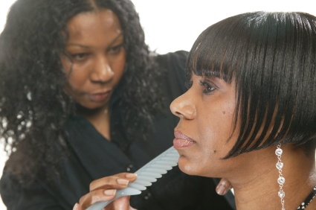

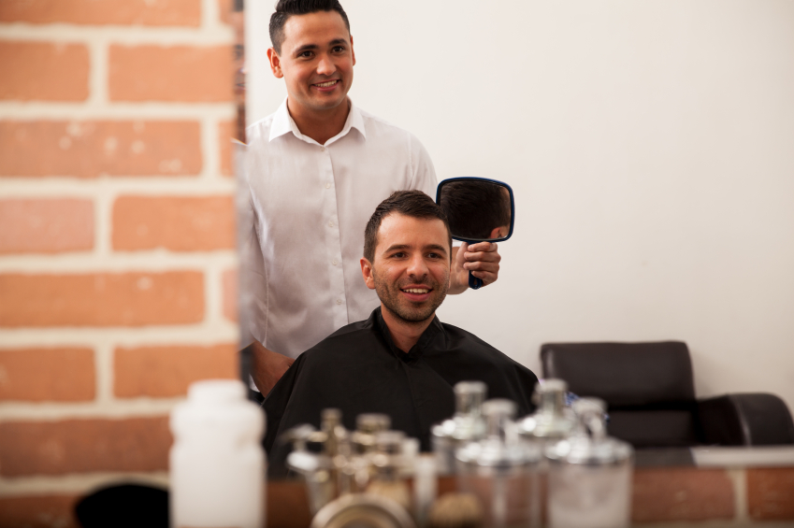

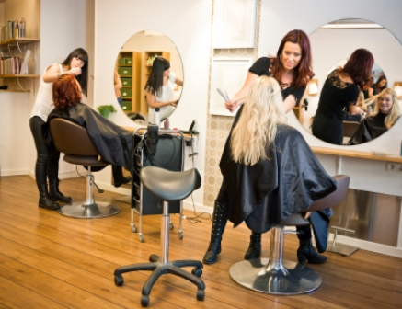

Resource 2 – Salon treatment vocabulary cards ✂

|  |  |  |  |
| --- | --- | --- | --- |
| 1 |  | | |
| 2 |  | | |
| 3 |  | | |
| 4 |  | | |
| 5 |  | | |
| 6 |  | | |
| 7 |  | **8** |  |
| 9 |  | **10** |  |

**Resource 3 - Salon price list**

|  |  |
| --- | --- |
| Scissors, Shears, Cut, Tool, Equipment, Sharp, HaircutPrice list Scissors, Shears, Cut, Tool, Equipment, Sharp, Haircut | |
| Gents   * Clippers * Dry cut * Wet cut * Beard trim * Wet shave | £6  £9  £12  £5  £8 |
| Ladies   * Wash and blow dry * Cut and style | £14  £20 |
| Other treatments   * Colour * Semi-permanent colour * Permanent colour * Cane rows * Weave / extensions | From £25  From £45  From £35  From £50 |
| Students get a 10% discount Mon to Thu.  We do wedding and special occasion hair. Please ask! | |
| For an appointment, call 0192 555 34521 | |

................................................................................................................................................................................................................Fold

Extra questions (if you have time)

1. How much is a gents’ dry cut?
2. How much is a ladies’ cut and style?
3. I am a student. Do I pay full price?
4. What number do I call for an appointment?

**Resource 4 – Price list information gap** ✂

|  |  |  |  |  |  |  |  |  |  |  |  |  |  |  |  |  |  |
| --- | --- | --- | --- | --- | --- | --- | --- | --- | --- | --- | --- | --- | --- | --- | --- | --- | --- |
| Resource 4A   |  |  | | --- | --- | | Scissors, Shears, Cut, Tool, Equipment, Sharp, Haircut Price list Scissors, Shears, Cut, Tool, Equipment, Sharp, Haircut | | | Gents   * Clippers * Cut * Beard trim * Wet shave | £4  ........  £7.95  ....... | | Ladies   * Wash and blow dry * Cut and style | £15.25  ....... | | Other treatments   * Semi-permanent colour * Permanent colour * Cane rows * Extensions | £19.99  £39.99  .......  ....... | | Resource 4B   |  |  | | --- | --- | | Scissors, Shears, Cut, Tool, Equipment, Sharp, Haircut Price list Scissors, Shears, Cut, Tool, Equipment, Sharp, Haircut | | | Gents   * Clippers * Cut * Beard trim * Wet shave | .......  £10  ......  £9.95 | | Ladies   * Wash and blow dry * Cut and style | .......  £25.75 | | Other treatments   * Semi-permanent colour * Permanent colour * Cane rows * Extensions | .......  .......  £32.99  £56.99 | |

**Resource 5a** – Task 1A – Look at the appointment cards. Tick the correct card.

**Dialogue 1**

|  |  |  |  |
| --- | --- | --- | --- |
| A⬜ | Scissors, Shears, Cut, Tool, Equipment, Sharp, HaircutAppointment card  Name: Martina  Your appointment is on Friday at 10.40  Treatment: Wash and blow dry  Stylist: Misha | B⬜ | Scissors, Shears, Cut, Tool, Equipment, Sharp, HaircutAppointment card  Name: Marta  Your appointment is on Friday at 10.30  Treatment: Cut and style  Stylist: Misha |

**Dialogue 2**

|  |  |  |  |
| --- | --- | --- | --- |
| A⬜ | Scissors, Shears, Cut, Tool, Equipment, Sharp, HaircutAppointment card  Name: Asan  Your appointment is on Tue at 3.45  Treatment: Wet cut and beard trim  Stylist: Misha | B⬜ | Scissors, Shears, Cut, Tool, Equipment, Sharp, HaircutAppointment card  Name: Hassan  Your appointment is on Thu at 4.15  Treatment: Wet cut  Stylist: Misha |

**Resource 5b** Task 1B – Listen and fill in the appointment cards.

|  |  |  |
| --- | --- | --- |
| Dialogue 1 |  |  |
| Scissors, Shears, Cut, Tool, Equipment, Sharp, HaircutAppointment card  Your appointment is on ........................................... …at .........................  Treatment: ................................................................................................................  .................................................................................................................  Stylist: Misha | | |
| Dialogue 2 | | |
| Scissors, Shears, Cut, Tool, Equipment, Sharp, HaircutAppointment card  Name: .............................................  Your appointment is on ........................................... …at .........................  Treatment: ................................................................................................................  ................................................................................................................. | | |

**Resource 6** – Transcript and sequencing activity (Making appointments listening activity)

|  |  |
| --- | --- |
| Dialogue 1 | |
| *Receptionist* | Hello. Can I help you? |
| *Marta* | Oh hello. Can I make an appointment for a cut and style please? |
| *Receptionist* | Sure. When would you like to come? |
| *Marta* | Have you got any appointments on Friday morning? |
| *Receptionist* | Let me check....There’s one with Misha at ten thirty. Is that OK? |
| *Marta* | Yes that’s fine, thanks. |
| *Receptionist* | What’s the name? |
| *Marta* | Marta. |
| *Receptionist* | No problem. We’ll see you then. |
| Marta | Thank you. Bye. |
| Dialogue 2 | |
| Receptionist | Hi. Can I help? |
| *Asan* | Yes. Could I have an appointment for a wet cut and a beard trim, please? |
| *Receptionist* | Certainly. When would you like to come? |
| *Asan* | Are there any appointments today? |
| *Receptionist* | Erm...I don’t think so. Let me check....Sorry we are really busy today. Can you come tomorrow afternoon? At quarter to four? |
| *Asan* | OK. That’s fine. |
| *Receptionist* | What’s the name? |
| *Asan* | Asan. |
| *Receptionist* | OK...just let me book that in...Tuesday...quarter to four. OK, Asan. See you then. |
| *Asan* | Thanks. Bye. |

**Resource 7a** – Appointment book

|  |  |
| --- | --- |
| Salon .......................................................... | |
| Friday | |
| Morning | **Afternoon** |
| 9.30 | **12.00** |
| 10.00 | **12.30** |
| 10.30 Kamal – dry cut | **1.00** |
| 11.00 | **1.30** |
| 11.30 | **2.00 Chan – full head colour** |

Fold or cut .....................................................................................................................................

**Resource 7b** – Appointments

* *Can I have an appointment, please?*
* *Monday at 2.00?*
* *OK.*
* *What’s your name?*
* *.....*
* Monday 3.00
* Wednesday 4.30
* Friday 11.00
* Saturday 10.30

**Resource 8** – Salon items

|  |  |  |  |
| --- | --- | --- | --- |
| C:\Users\Ali\Dropbox\EMW_images (1)\Nexus istock images\hairbrush_iStock_000017500510XSmall.jpg |  | | |
|  |
|  | **C:\Users\Ali\Dropbox\EMW_images (1)\Nexus istock images\towels_iStock_000016866765XSmall.jpg** |  | **C:\Users\Ali\Dropbox\EMW_images (1)\Nexus istock images\hairdressser's_sink_iStock_000019918556XSmall.jpg** |

.........................................................................................................................................................................................Fold

|  |  |  |  |
| --- | --- | --- | --- |
| scissors | clip | hairspray | straighteners |
| hairdryer | **brush** | **water spray** | **comb** |
| basin | **towel** | **clippers** | **razor** |
| pintail comb | **shampoo** | **shaving foam** | **shaving brush** |

**Resource 9 Texts**– Reading salon texts

2

1



**Instructions for use**

Wet hair. Massage shampoo into hair. Rinse hair and repeat.

If shampoo gets into eyes, rinse eyes with water immediately.

3

|  |  |  |  |
| --- | --- | --- | --- |
| Salon Supplies | Item | Quantity | Price |
| C:\Users\Ali\Dropbox\EMW_images (1)\Nexus istock images\hairbrush_iStock_000017500510XSmall.jpg | Salon brush  £5.99 each | 5 | £29.95 |
|  | Straighteners  £59.99 each | 2 | £119.98 |
|  | Deluxe shampoo (250 ml)  £3.50 each | 5 | £17.50 |
|  | **Subtotal** |  | £167.43 |
|  | \*FREE DELIVERY\* |  | £0.00 |
|  | **Total** | **Order now** | £167.43 |

**Resource 9 Activity** - Reading salon texts

**Task 1A**

1. Which text...

* do you use to buy things for your salon?
* tells you to be careful?
* gives you instructions?

1. Look at Text 3.
2. How much are the straighteners?
3. How many brushes do I want?
4. How big is a bottle of shampoo?
5. How much is delivery?

...............................................................................................................................................................................................Fold or cut

**Task 1B**

1. What is the purpose of each text?

Text A .................................................................................................................

Text B .................................................................................................................

Text C .................................................................................................................

1. Look at Text 3.
2. How much are the straighteners?
3. How many brushes do I want?
4. How big is a bottle of shampoo?
5. How much is delivery?
6. Look at the texts again. Find words which the same as...

*wash with water how many warning / be careful*

**Resource 10 –** Talking to your client

Is it OK to say these things to a client? Tick (✓) or a cross (🗶) each sentence. If you aren’t sure, put a question mark (?).

1. Please have a seat.
2. Sit here.
3. Can I get you a drink?
4. How are you today?
5. Your hair looks terrible.
6. Did you watch the football last night?
7. What do you do?
8. How much money do you make?
9. Could you put your head forward, please?
10. You look like you’ve put on some weight.
11. Have you got kids?
12. Why haven’t you got kids?
13. Have you tried this shampoo?
14. Have you been busy today?
15. Come here.
16. Would you like to come over to the basin?

...................................................................................................................................................................................................Fold

Extra activity (if you have time)

You don’t know your client very well. Which are good topics to talk about? Which are not good topics? Put a tick (✓) or a cross (🗶).

|  |  |
| --- | --- |
| * holidays * work * religion * politics * television * health | * weather * free time * sport * sex and relationships * music * money |

Can you think of any other good topics to talk about with your client?

........................................................................................................................................

........................................................................................................................................